TASK 4 – Control implicit conversions
Implicit conversion happens when C++ changes a value's type automatically. In the given program, a / b is integer division because both operands are int. Assigning the result to double does not restore the discarded fraction. static_cast<double>(a) / b converts a before division and gives 3.5. A char used in arithmetic is promoted to int. Assigning 5 to bool produces true. Comparing signed -1 with unsigned 1 converts the signed value to unsigned, so the comparison is false on the usual unsigned conversion rules.
Complete program supplied in the assignment
#include <iostream>
int main() {
int a = 7, b = 2;
double c = a / b;
double d = static_cast<double>(a) / b;
std::cout << c << ' ' << d << '\n';
char ch = 'A' + 2;
std::cout << ch << ' ' << ch + 1 << '\n';
bool flag = 5;
std::cout << flag << ' ' << std::boolalpha << flag << '\n';
unsigned int u = 1;
int s = -1;
std::cout << (s < u ? "s < u" : "s >= u") << '\n';
}

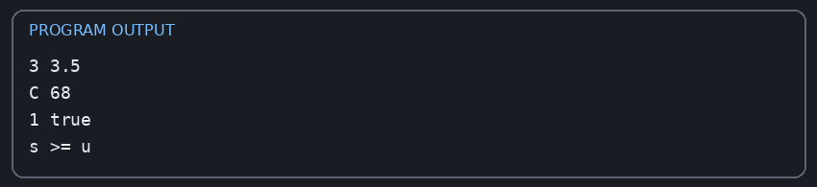
Expected output on a typical g++ implementation:
3 3.5
C 68
1 true
s >= u

Explanation: 3 is printed for c because 7/2 is integer division; 3.5 is printed for d; C is the character with code value two greater than A; ch + 1 prints the integer code of the next character; bool prints 1 and then true after boolalpha; -1 converts to a large unsigned value, so s < u is false.

Alternative concept and complexity
Writing conversions explicitly with static_cast and using brace initialization makes intentions clearer and catches narrowing at compile time. The runtime time and memory are normally unchanged because casts do not add meaningful work in these examples. Compile-time errors are preferable to silently losing a fractional part.

